**Bike store dataset**

Link: <https://www.kaggle.com/datasets/dillonmyrick/bike-store-sample-database>?

1. List all customers from California, ordered by last name

SELECT customer_id, first_name, last_name, city, state

FROM customers

WHERE state = 'CA'

ORDER BY last_name ASC;

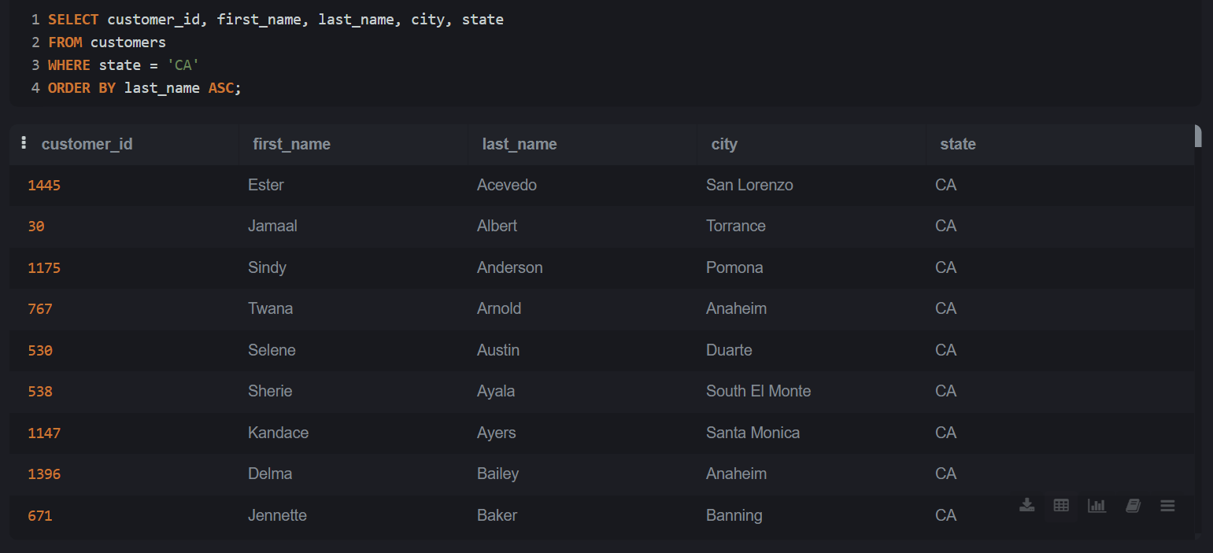

1. Total number of orders per store

SELECT store_id, COUNT(order_id) AS total_orders

FROM orders

GROUP BY store_id

ORDER BY total_orders DESC;

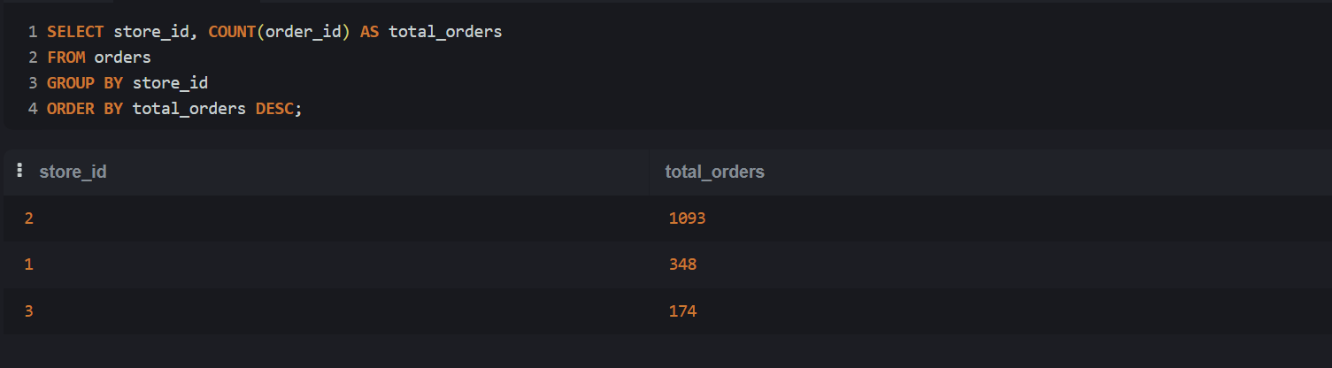

1. INNER JOIN: Orders with customer and staff details

SELECT

o.order_id,

c.first_name AS customer_name,

s.first_name AS staff_name,

o.order_date,

o.order_status

FROM orders o

INNER JOIN customers c ON o.customer_id = c.customer_id

INNER JOIN staffs s ON o.staff_id = s.staff_id;

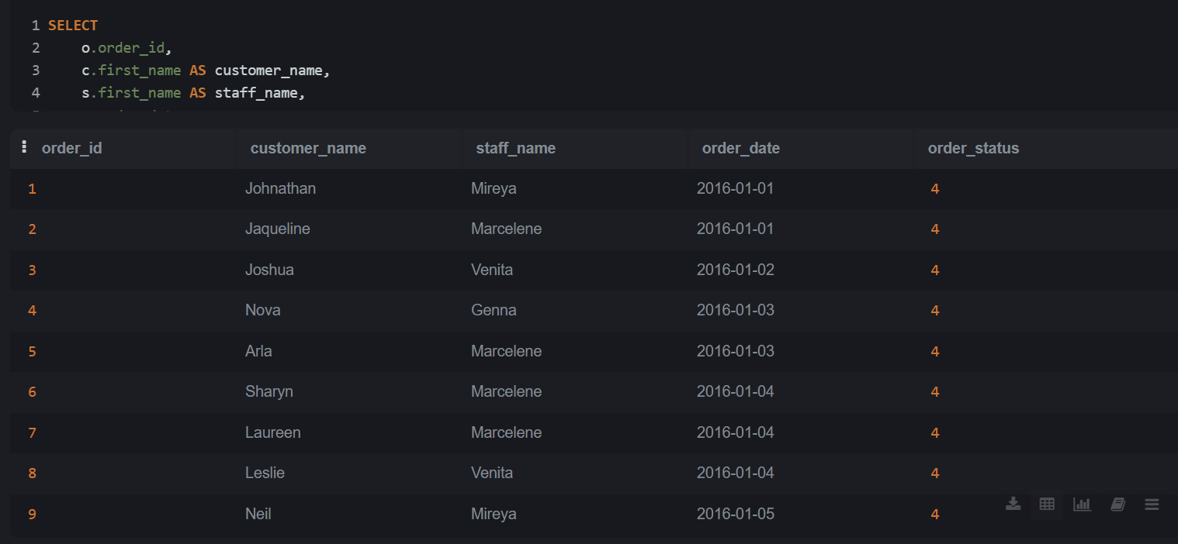

1. LEFT JOIN: List all products with their stock quantity

SELECT

p.product_name,

b.brand_name,

s.quantity

FROM products p

LEFT JOIN stocks s ON p.product_id = s.product_id

LEFT JOIN brands b ON p.brand_id = b.brand_id;

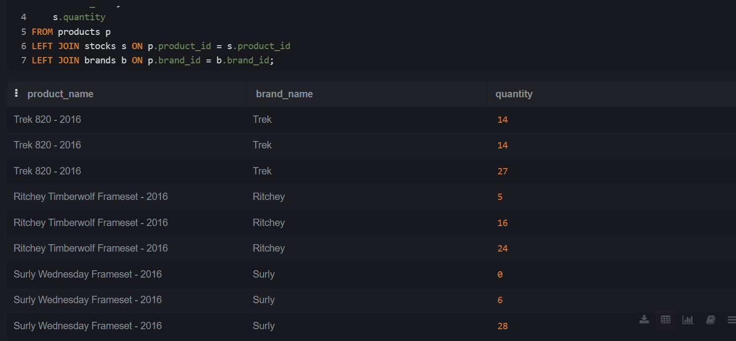

1. RIGHT JOIN: All brands even if no products exist

SELECT

b.brand_name,

p.product_name

FROM products p

RIGHT JOIN brands b ON p.brand_id = b.brand_id;

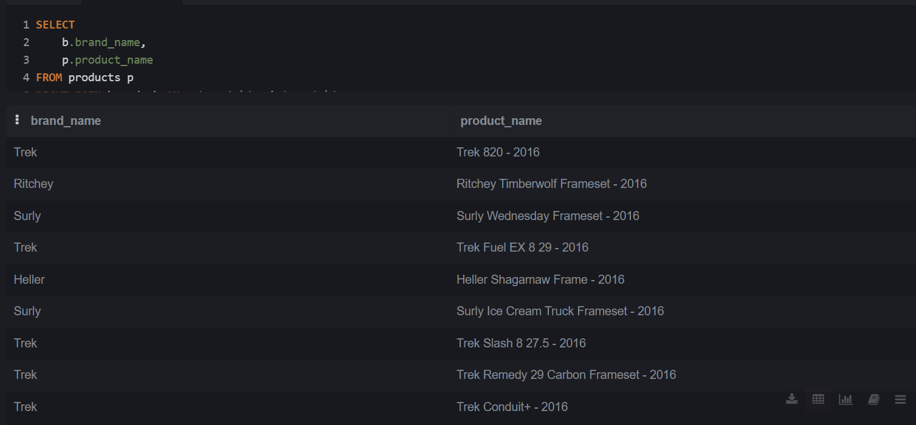

1. Find products that are above average list price

SELECT product_name, list_price

FROM products

WHERE list_price > (SELECT AVG(list_price) FROM products);

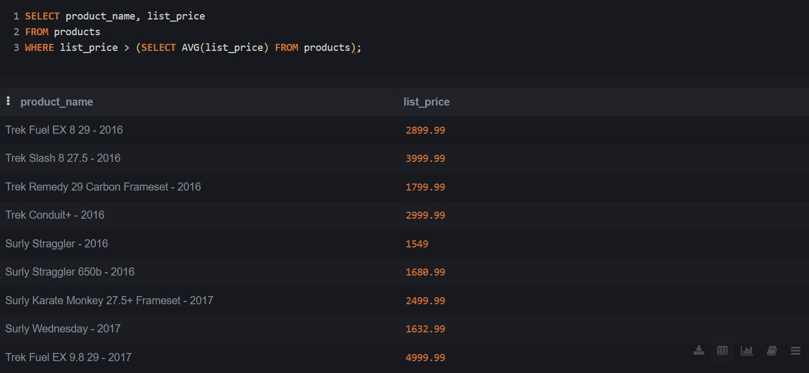

1. Calculate total sales and average discount per order

SELECT

order_id,

SUM(quantity * list_price * (1 - discount)) AS total_sales,

AVG(discount) AS avg_discount

FROM order_items

GROUP BY order_id;

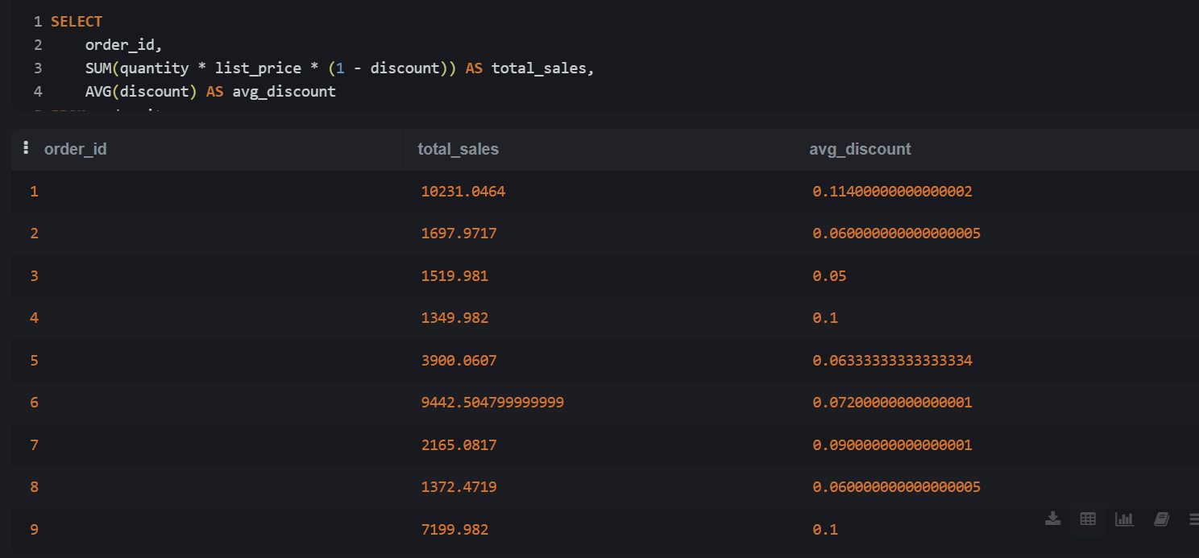

1. Average list price per category

SELECT

c.category_name,

AVG(p.list_price) AS avg_price

FROM products p

INNER JOIN categories c ON p.category_id = c.category_id

GROUP BY c.category_name

ORDER BY avg_price DESC;

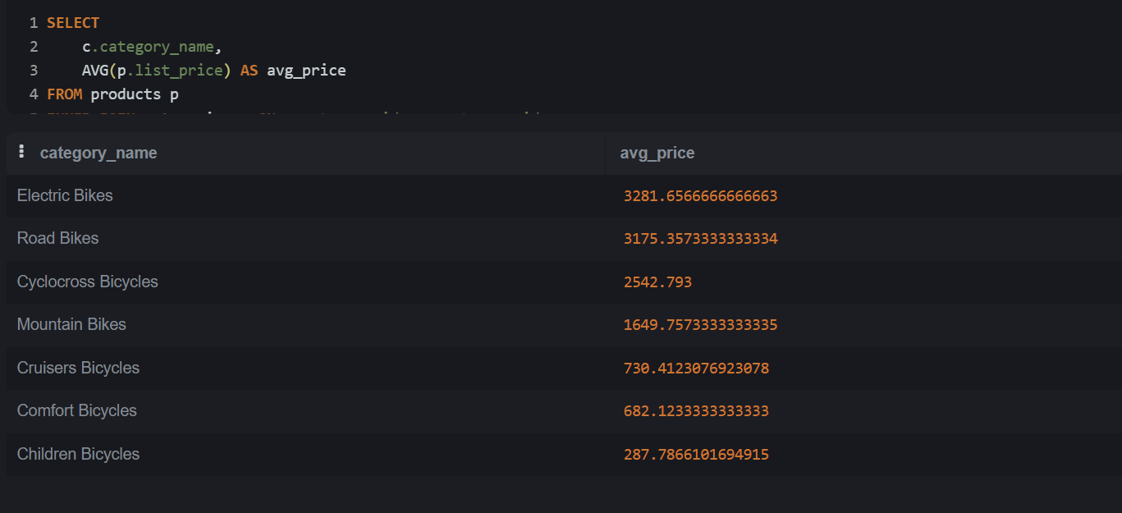

1. View: Customer order summary

CREATE VIEW v_customer_orders AS

SELECT

c.customer_id,

c.first_name,

c.last_name,

COUNT(o.order_id) AS total_orders,

SUM(oi.quantity * oi.list_price * (1 - oi.discount)) AS total_spent

FROM customers c

JOIN orders o ON c.customer_id = o.customer_id

JOIN order_items oi ON o.order_id = oi.order_id

GROUP BY c.customer_id, c.first_name, c.last_name;

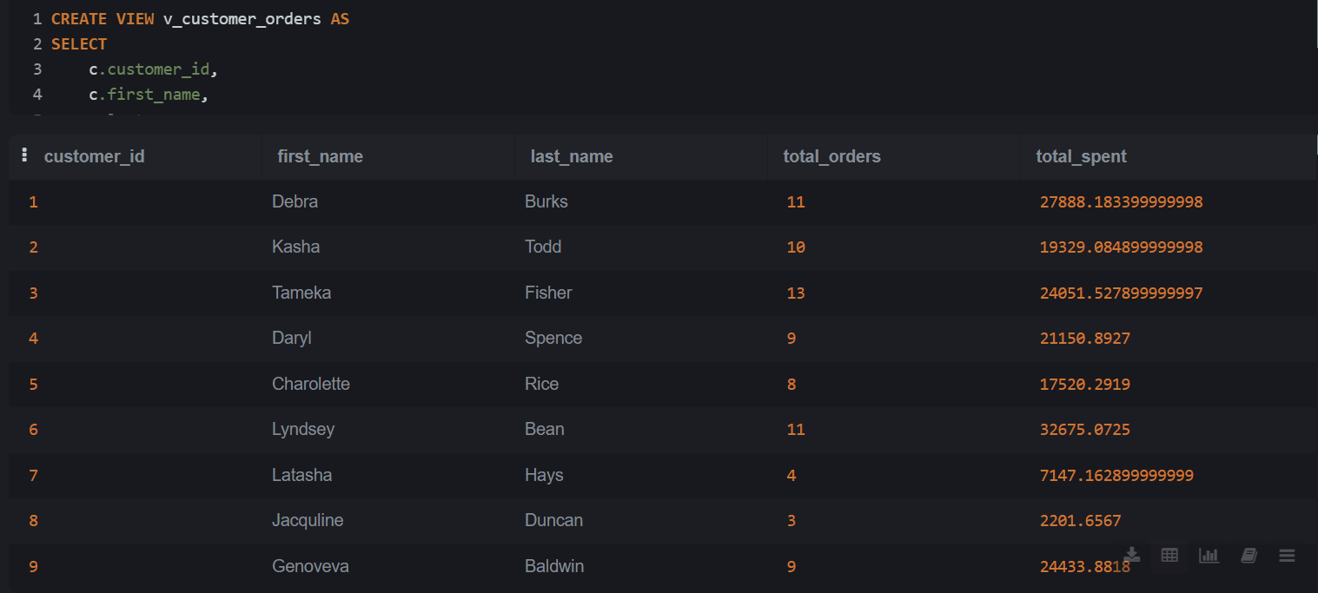

1. Top 5 best-selling products (by total quantity)

SELECT

p.product_name,

SUM(oi.quantity) AS total_sold

FROM order_items oi

JOIN products p ON oi.product_id = p.product_id

GROUP BY p.product_name

ORDER BY total_sold DESC

LIMIT 5;

